**LAB : 4**

**OBJECTIVE :**

1. Extend the class diagram of Book to include the following attributes:

• a book includes a publisher, publication date, and an ISBN

• a part includes a title and a number

• a chapter includes a title, a number, and an abstract

• a section includes a title and a number

1. Consider the class diagram of above question. Note that the Part, Chapter, and Section classes all include a title and a number attribute. Add an abstract class and a generalization relationship to factor out these two attributes into the abstract class.

**Requrements :**

(a) Windows PC (Windows 7/8/10) / Mac

(b) Star UML Tool

**Procedure :**

1. Extend the class diagram of Book to include the given attributes

• a book includes a publisher, publication date, and an ISBN

• a part includes a title and a number

• a chapter includes a title, a number, and an abstract

• a section includes a title and a number

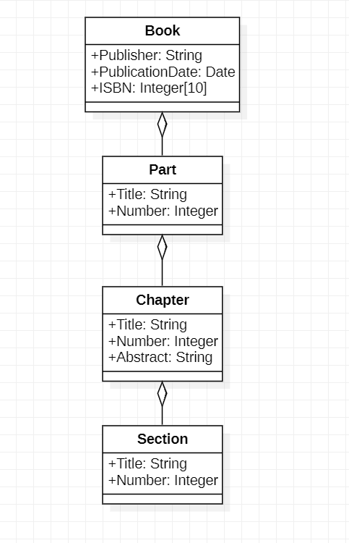

1. Consider the class diagram of above question. Note that the Part, Chapter, and Section classes all include a title and a number attribute. Add an abstract class and a generalization relationship to factor out these two attributes into the abstract class.

